**23.40 Step 40**

The system will boot to a point, and then an error message will appear:

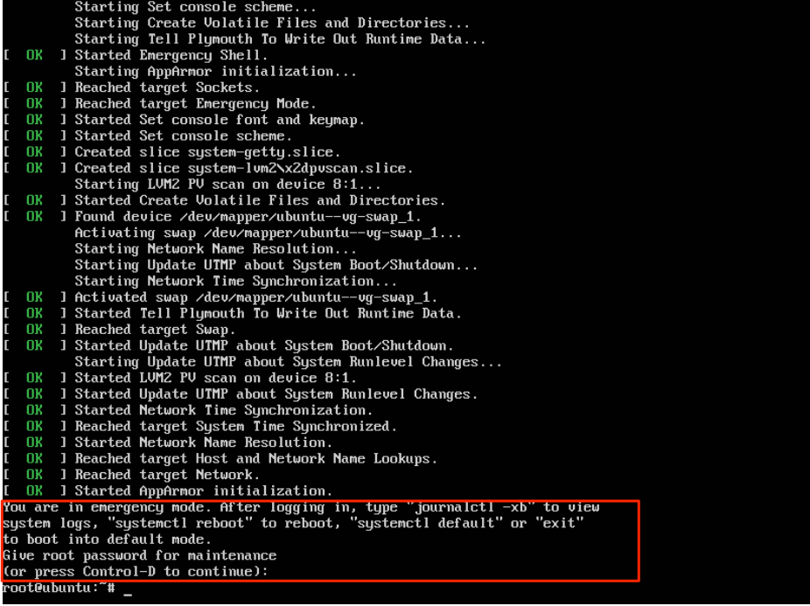

Because this filesystem is a non-critical filesystem (not needed to boot the system), you *could* press the letter S, and the mounting process for this filesystem would be skipped. You could then login and fix the problem by running the fsck command. However, if it was a critical filesystem, you wouldn't be able to do that. For this lab, consider this a critical filesystem.